**Vishwavijay (1/16/FET/BCG/1/002)**

**Simulation And Modelling Lab**

**EXPERIMENT 1 (Pure Pursuit Problem)**

**CODE**

xb=[80;90;99;108;116;125;133;141;151; 160;169;179;180]

yb=[0;-2;-5;-9;-15;-18;-23;-29;-28;-25;-21;-20;-17]

xf=0

yf=50

V=20

function [**D**]=Dist(**XB**, **YB**, **XF**, **YF**)

**D**=sqrt((**YB**-**YF**)^2+(**XB**-**XF**)^2) // error was here

endfunction

function [**xf**, **yf**]=NextPos(**XB**, **YB**, **XF**, **YF**, **V**)

[d]=Dist(**XB**,**YB**,**XF**,**YF**)

sin0=(**YB**-**YF**)/d

cos0=(**XB**-**XF**)/d

**xf**=**XF**+**V**\*cos0

**yf**=**YF**+**V**\*sin0

endfunction

for i=1:12

[d]=Dist(xb(i),yb(i),xf,yf)

disp(d)

if d <=10 then

disp("bombed")

break

elseif i > 12 then *//error was here*

disp("bomber escaped")

else

[xf,yf]=NextPos(xb(i),yb(i),xf,yf,V)

end

end;

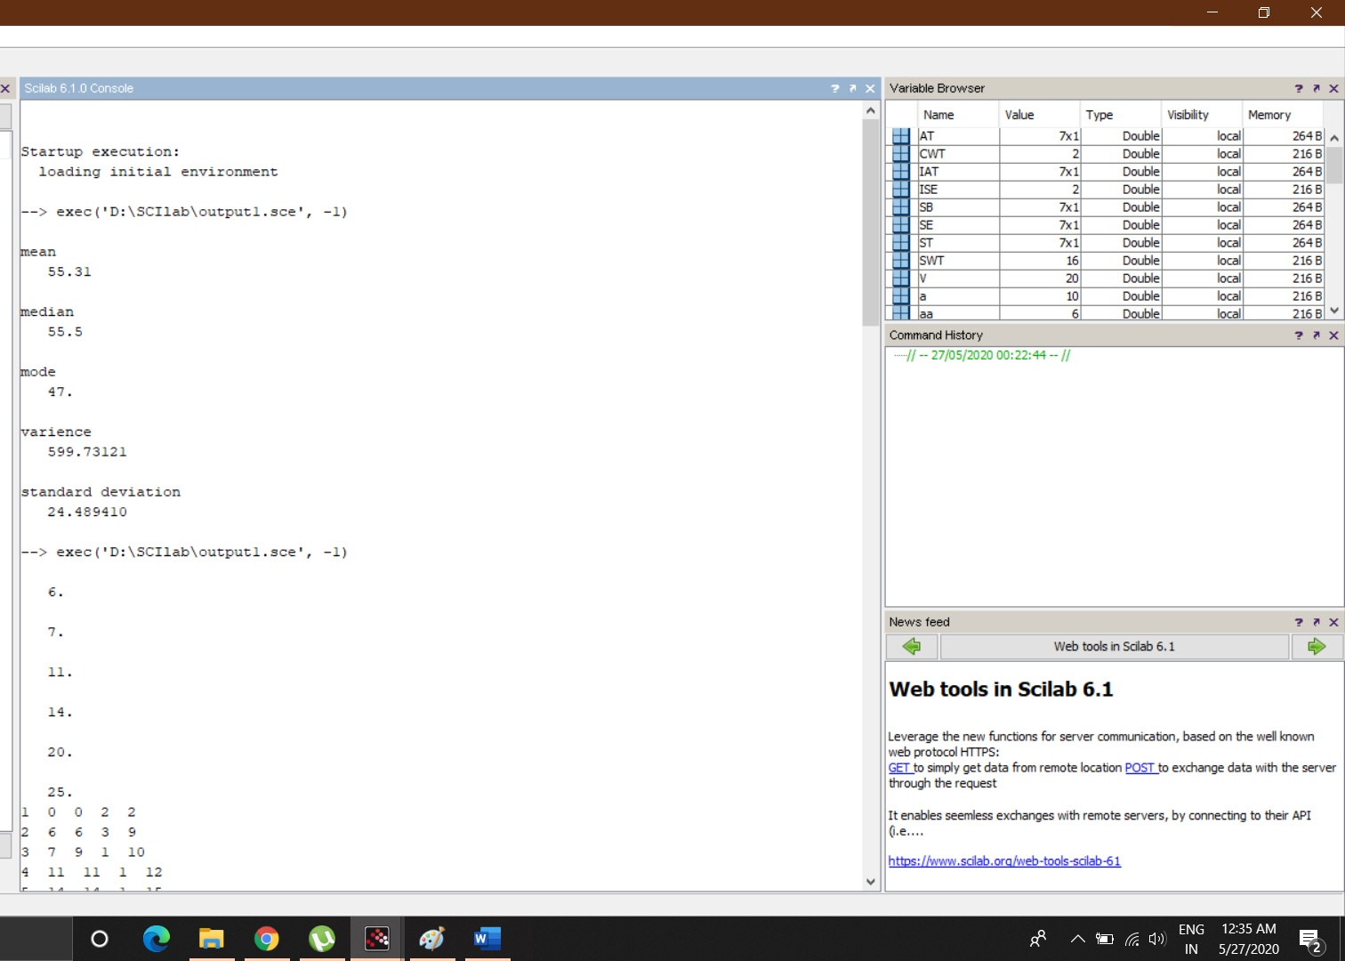

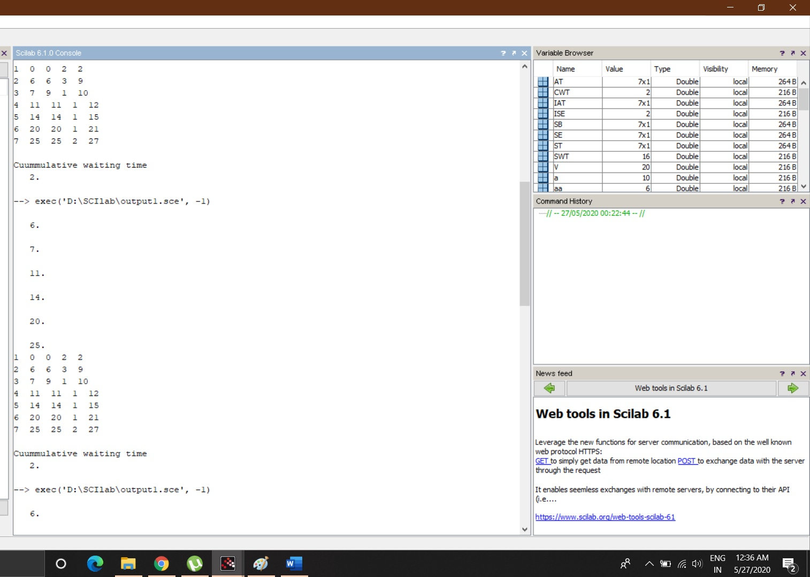

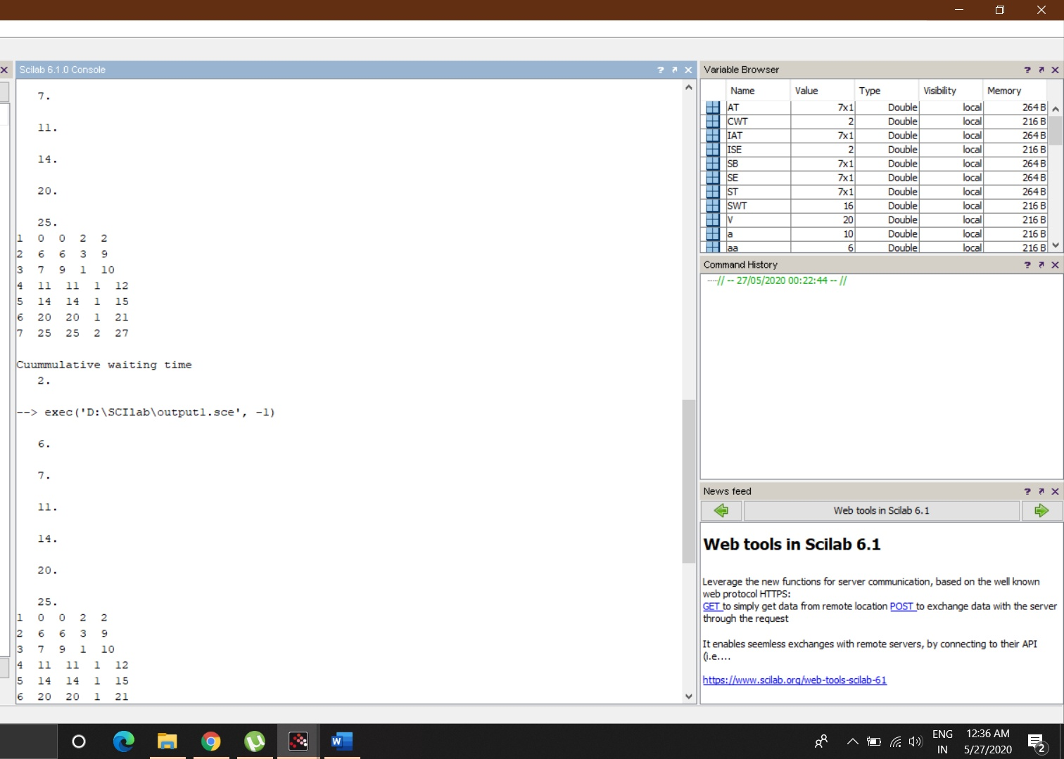

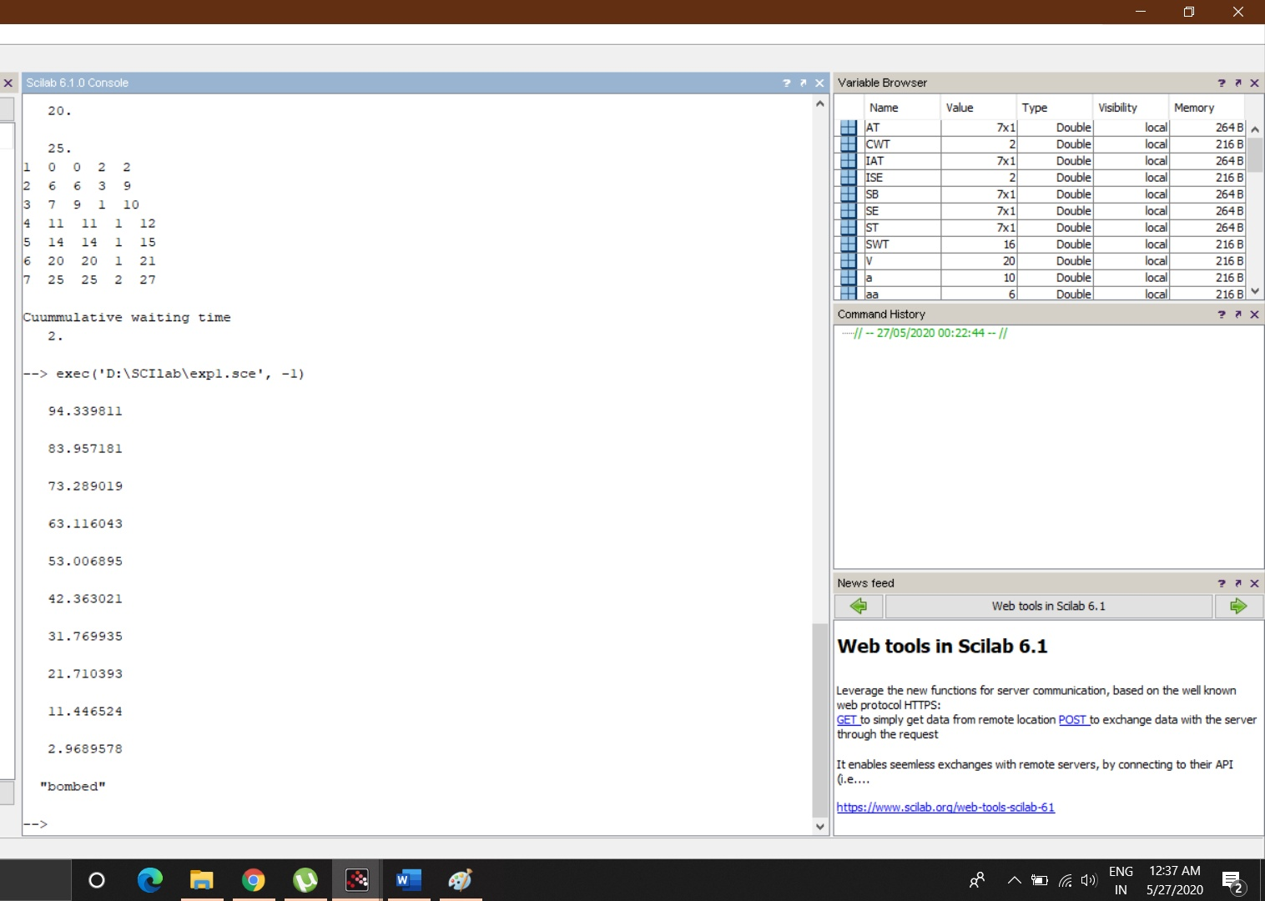

**Experiment 2**

1. **Single Server Queue**
2. **Random No (LCG)**
3. **Code**

IAT=[0;6;1;4;3;6;5]

ST=[2;3;1;1;1;1;2]

SWT=0

CWT=0

SB=[0;0;0;0;0;0;0]

AT=[0;0;0;0;0;0;0;]

ISE=AT(1)+ST(1)

SE=[0;0;0;0;0;0;0]

SE(1)=ISE

for i=2:7

AT(i)=AT(i-1)+IAT(i)

disp(AT(i))

end;

for i = 2:7

if AT(i)<SE(i-1) then

CWT=CWT+(SE(i-1)-AT(i))

SB(i)=SE(i-1)

SE(i)=SE(i-1)+ST(i)

else

SWT=SWT+AT(i)-SE(i-1)

SB(i)=AT(i)

SE(i)=AT(i)+ST(i)

end;

end;

for i=1:7

mprintf('%d %d %d %d %d\n', i ,AT(i),SB(i),ST(i),SE(i))

end;

printf('\nCuummulative waiting time')

disp(CWT)

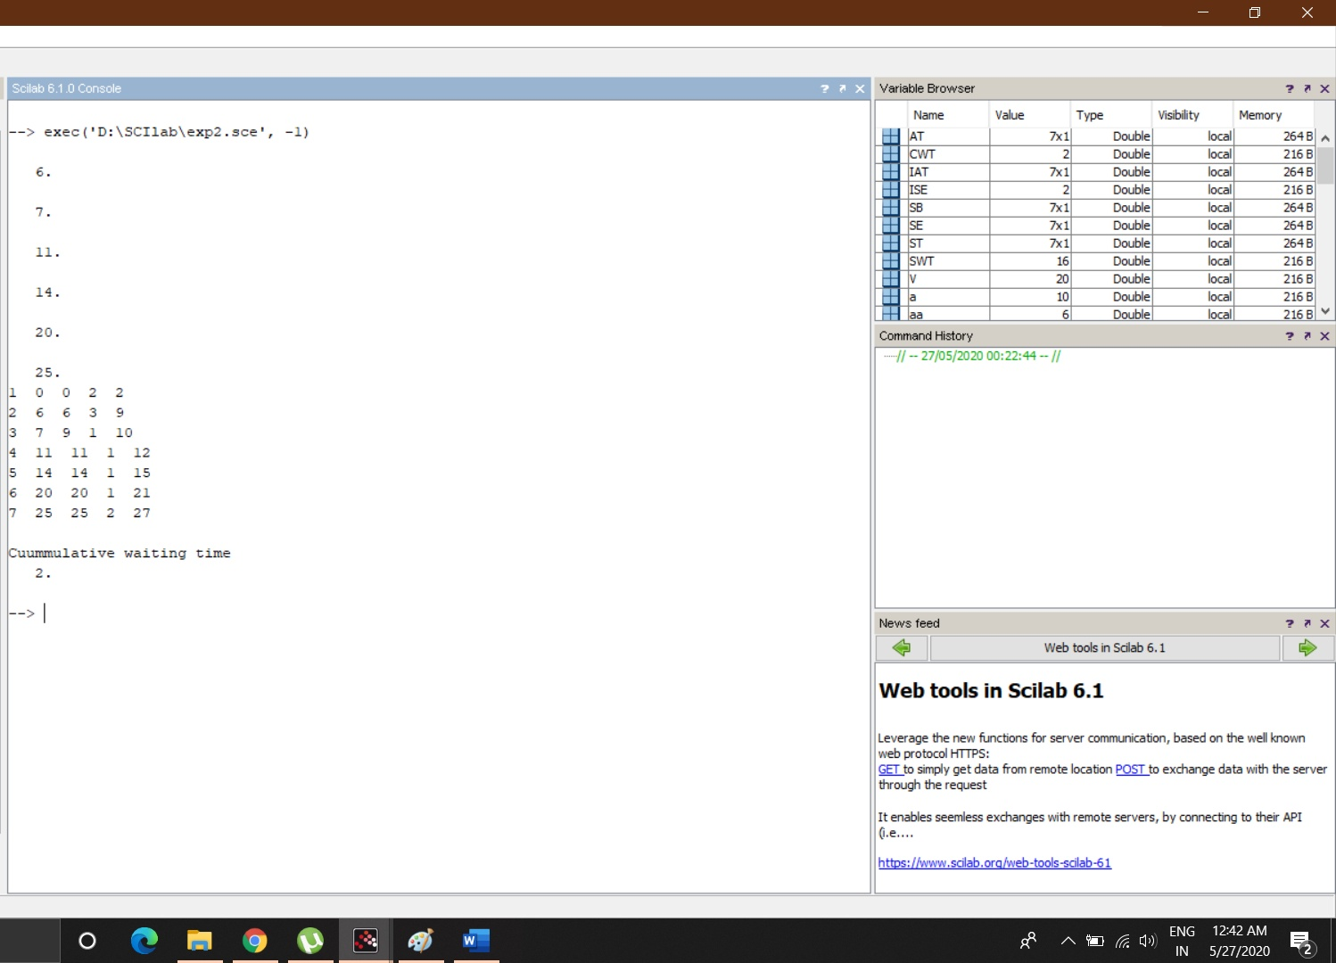

**B) CODE**

a= 4

c= 3

m=8

X=[0]

for i=1:m

z=(a*X(i)+c)

X(i+1)=modulo(z,m)

end

disp(X)

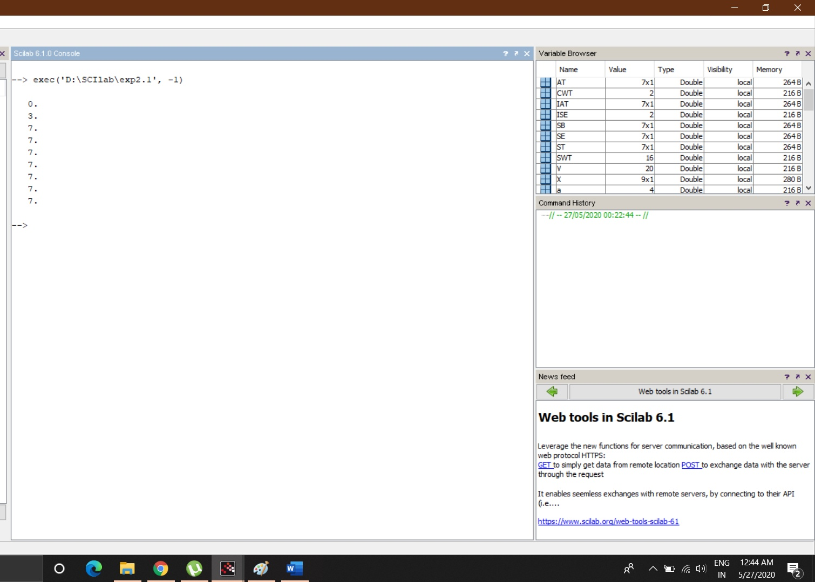

**EXPERIMENT 3**

1. **Given the age of different persons with their frequencies, calculate simple mean of age and plot graph between age and frequency.**
   1. **Generate a list of 100 random numbers between 10-100 representing the age of the people. Draw the bar graph of people between the age of 10-20, 21-30,31-40, 41-50,51-60,61-70,71-80,81-90,91-100.**
   2. **Calculate the following statistics of the people mean, median, mode , variance, standard deviation of complete data in scilab.**

**CODE**

a=10;

b=100;

w=100

r=[];

d=[];

e=[];

f=[];

g=[];

h=[];

i=[];

j=[];

k=[];

l=[];

aa=0;

bb=0;

cc=0;

dd=0;

ee=0;

ff=0;

gg=0;

hh=0;

ii=0;

for z=1:w

r(z)=ceil(a+(b-a)*rand());

end,

*//printf("AGE\n")*

*//disp(r);*

for z=1:w

if r(z)<=20 then

d(z)=r(z)

aa=aa+1

elseif r(z)>20&&r(z)<=30 then

e(z)=r(z)

bb=bb+1

elseif r(z)>30&&r(z)<=40 then

f(z)=r(z)

cc=cc+1

elseif r(z)>40&&r(z)<=50 then

g(z)=r(z)

dd=dd+1

elseif r(z)>50&&r(z)<=60 then

h(z)=r(z)

ee=ee+1

elseif r(z)>60&&r(z)<=70 then

i(z)=r(z)

ff=ff+1

elseif r(z)>70&&r(z)<=80 then

j(z)=r(z)

gg=gg+1

elseif r(z)>80&&r(z)<=90 then

k(z)=r(z)

hh=hh+1

elseif r(z)>90&&r(z)<=100 then

l(z)=r(z)

ii=ii+1

end,

end

printf("\nmean")

m=mean(r)

disp(m)

printf("\nmedian")

n=median(r)

disp(n)

printf("\nmode")

q= tabul(r)

[n,i]=max(q(:,2))

amode=q(i,1)

disp(amode)

printf("\nvarience")

o=variance(r)

disp(o)

printf("\nstandard deviation")

p=stdev(r)

disp(p)

x=[20;30;40;50;60;70;80;90;100]

y=[aa;bb;cc;dd;ee;ff;gg;hh;ii]

bar(x,y)

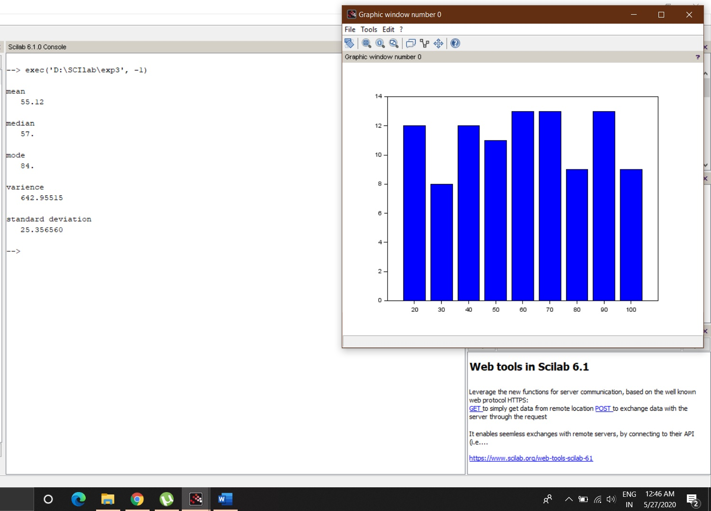

**2. To find the Covariance and Correlation For age and frequency Where**

* 1. **age==[46,53,29,61,36,39,47,49,52,38,55,32,57,54,4 4] and**
  2. **Frequency = [12,15,7,17,10,11,11,12,14,9,16,8,18,14,12];**

**CODE**

age=[46;53;29;61;36;39;47;49;52;38;55;32;57;54;44]

Frequency = [12;15;7;17;10;11;11;12;14;9;16;8;18;14;12];

c=cov(age,Frequency)

d=correl(age,Frequency)

printf("covarience\n")

disp(c)

printf("\ncorrelation\n")

disp(d)

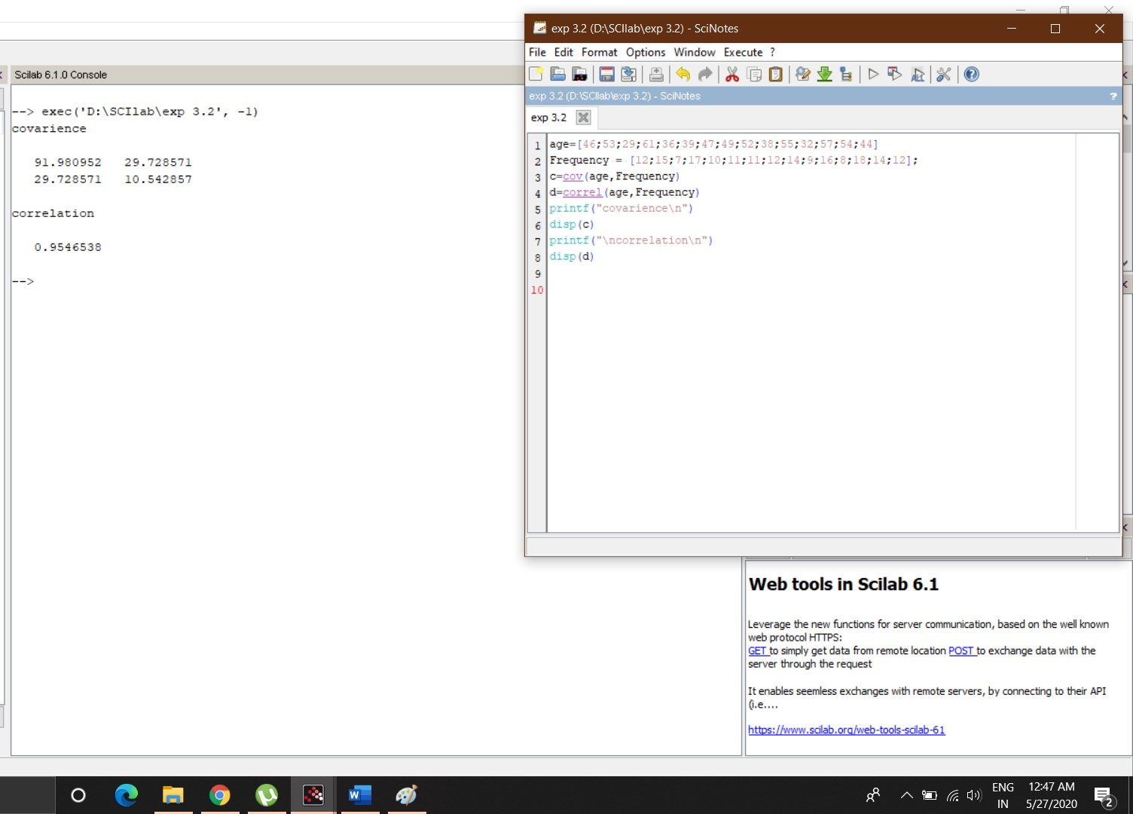

**3. We have a about vehicle performance. Miles per gallon is represented by matrix m and corresponding weight of car is represented by W matrix. Find covariance and correlation between these parameters. Plot the data set.**

* 1. **Create two arrays of random numbers representing the weight array and performance array.**
  2. **The weight of the vehicle can be 1000Kg -6000Kg**
  3. **Performance of the vehicle can vary between 6-15gallons/miles**

**CODE**

n=20;

a=1000;

b=6000;

m=[];

for z=1:n

m(z)=ceil(a+(b-a)*rand());

end,

printf("performance\n")

disp(m);

c=6;

d=15;

w=[];

for y=1:n

w(y)=ceil(c+(d-c)*rand());

end,

printf("\nweight\n")

disp(w);

e=cov(m,w)

f=correl(m,w)

printf("covarience\n")

disp(e)

printf("\ncorrelation\n")

disp(f)

plot(w,m)

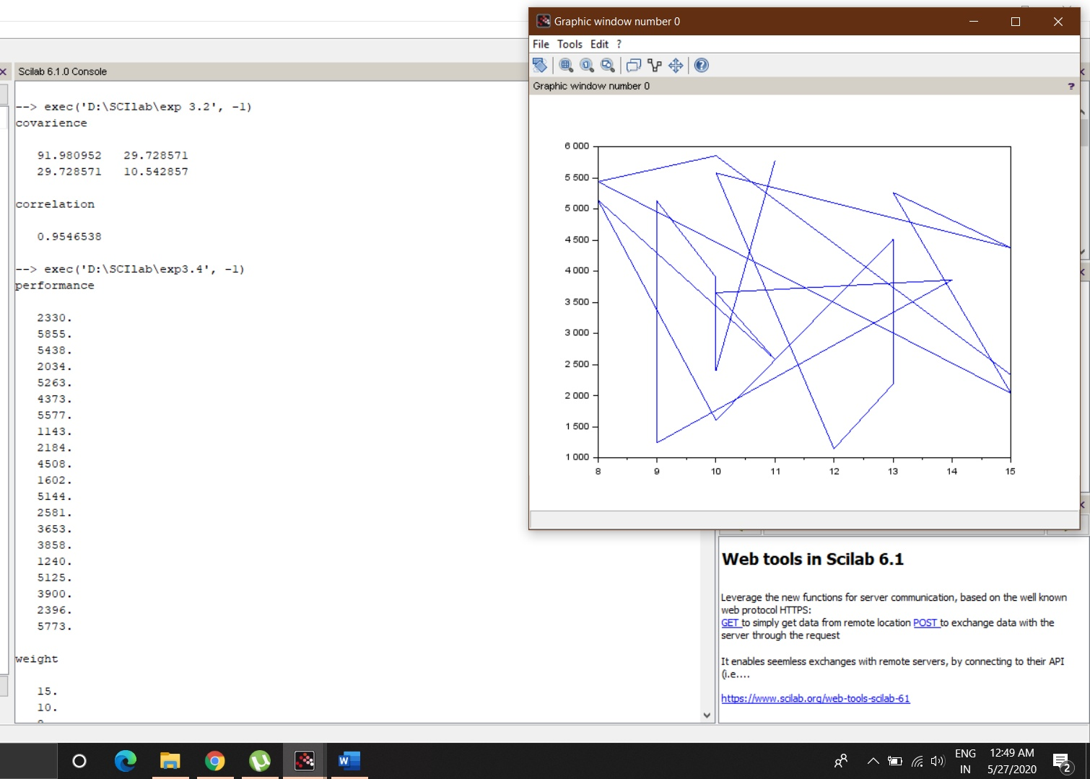

**EXPERIMENT 5**

**QUESTION:** Find out the values of various parameters in Car service centre, when two service workstation are there for service. The average number of cars being serviced are 10 cars/day and it takes on an average 6 hours to repair a car.

**CODE**

AR=10/24

SR=6

Po=1/(1+(AR/SR)+((AR/SR)^2)*(SR/((2*SR)-AR)))

Pb=(1/2)*((AR/SR)^2)*(2*SR/((2*SR)-AR))*Po

Lq=(AR*SR*((AR/SR)^2)*Po)/(((2*SR)-AR)^2)

L=Lq+(AR/SR)

Wq=(SR*((AR/SR)^2)*Po)/(((2*SR)-AR)^2)

W=Wq+(1/SR)

printf("\nProbability that system is empty=")

disp(Po)

printf("Probability that both server are busy-")

disp(Pb)

printf("avg. number in queue=")

disp(Lq)

printf("avg. number in system=")

disp(L)

printf("avg. time in queue=")

disp(Wq)

printf("avg. time in system=")

disp(W)

